SWIGGY FOOD DELIVERY PERFORMANCE ANALYSIS

1. Project Overview
This project analyze a Swiggy food delivery dataset, enriched with attributes such as customer segments, membership, restaurant type, platform fees, delivery fees, coupons, and delay indicators.
The goal is to understand Customer ordering behavior, Restaurant performance, Delivery efficiency, Revenue trends, Coupon impact, Operational bottlenecks
A complete analytics workflow was performed using Python, SQL, and Power BI.

2. Project Objectives
1. Study customer demand patterns across cities, cuisines, segments, and hours.
2. Analyze delivery performance (speed, distance impact, partner-wise efficiency).
3. Identify restaurant performance and cuisine popularity.
4. Evaluate coupon usage, offers effectiveness, and customer retention.
5. Build a 4-page Power BI dashboard for stakeholders.
6. Generate actionable insights to optimize Swiggy-like operations.

3. Dataset Description
The dataset contains 10,000 orders with enhanced fields.
Core Fields
- order_id, order_datetime, order_amount, discount_amount, TotalPayable
- delivery_time_mins, prep_time_mins, distance_km
- restaurant_name, restaurant_type, cuisine, city
- delivery_partner, delivery_status, rating
Extended Fields
- customer_age_group, customer_type, customer_segment
- customer_membership (Normal / Swiggy One)
- coupon_code_used, delivery_fee, platform_fee
- is_first_order, is_repeat_customer
- IsDelayed, ExpectedDelivery, DelayedMins

4. Tools Used
1. Python: Data Cleaning, Exploratory Data Analysis, Feature Engineering, Summary Statistics
2. SQL: Operational Analytics, Revenue Insights, Customer Segmentation, Delivery Performance Queries.
3. Power BI: Interactive Dashboard, Story Telling & Insights

5. Python Exploratory Data Analysis Insights
Customer Insights
- Peak ordering hours: 1 PM and 8 PM
- Most active cities: Mumbai, Delhi, Bangalore
- Top customer segment: Regular
- Swiggy One users have higher average spending

Restaurant Insights
- Top cuisines: Fast Food, Italian, Biryani
- Cloud Kitchens deliver faster than Dine-in outlets
- Some restaurants consistently cause delay due to prep time
Delivery Insights
- Avg delivery time: 25–45 mins
- Distance and prep time strongly influence delays
- Delivery Partner performance has noticeable variance:
  - Best partners achieve 95%+ on-time delivery
  - Slowest partners drop to 70–75%
Revenue Insights
- Highest revenue generated from:
  - Premium customers
  - Swiggy One members
  - Fast Food & Biryani cuisines
Offer Insights
- 35–40% orders use coupons
- Coupons increase order volume
- But reduce average order value

7. Power BI Dashboard
Page 1 – Executive Overview
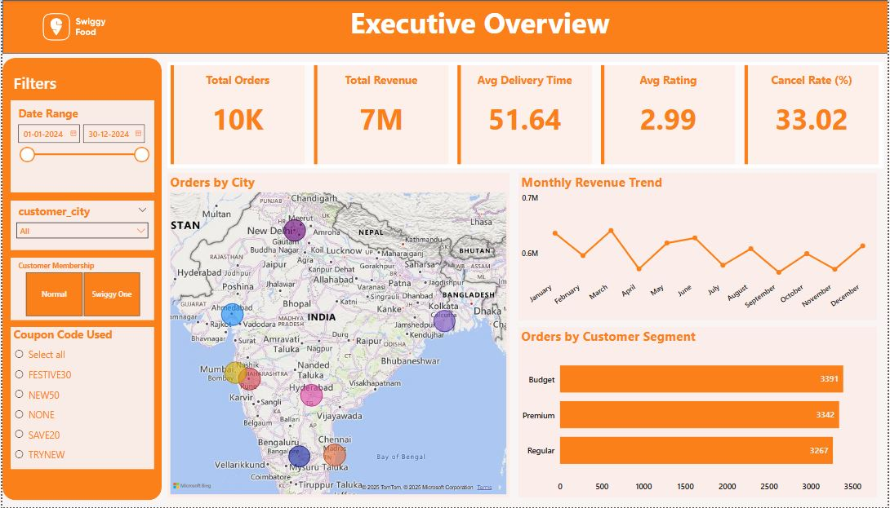
Page 2 – Customer & Revenue Insights
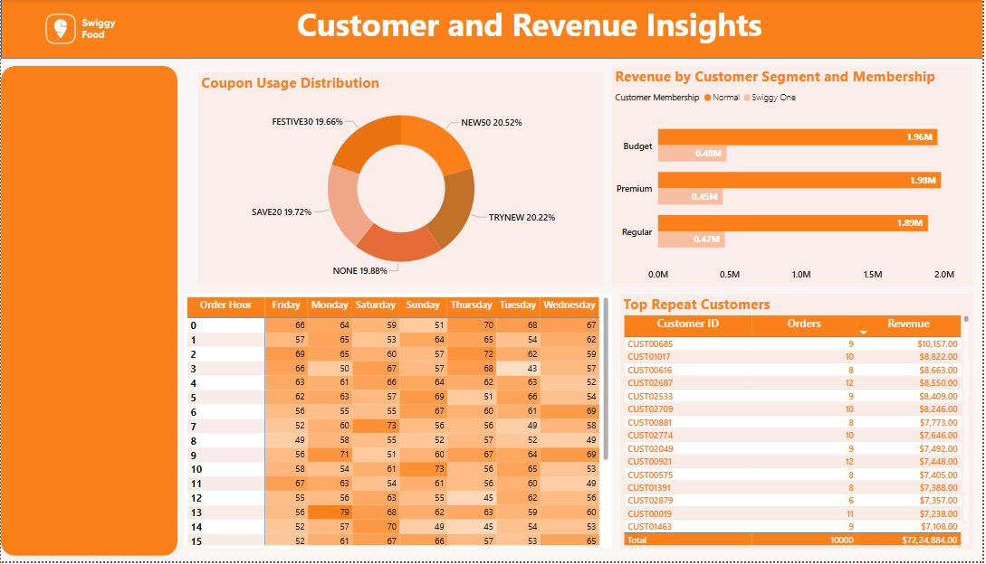

Page 3 – Delivery Operations
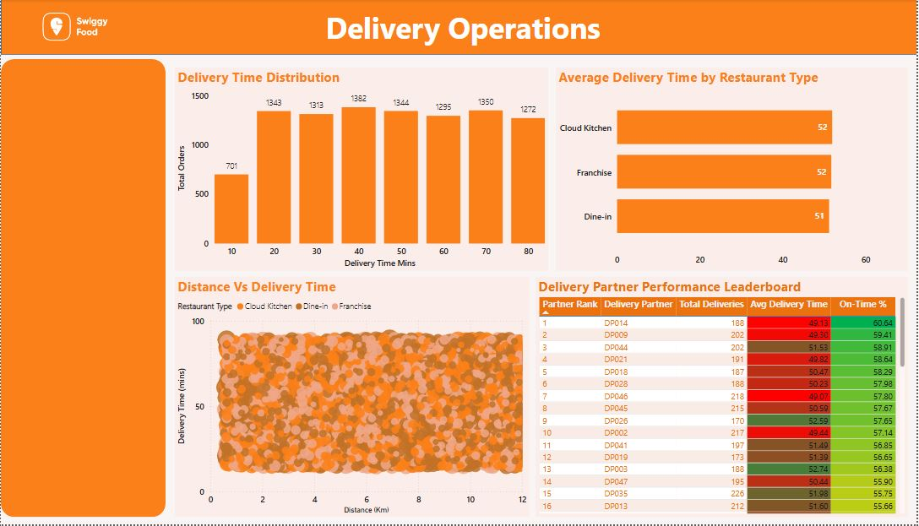

8. Key Insights & Findings
⭐ Customer Behavior
- Evening peak (7 PM–9 PM): highest orders
- Premium segment contributes 45%+ revenue
- Swiggy One users order 25% more frequently
⭐ Delivery Efficiency
- Orders above 6 km have significantly higher delays
- Cloud kitchens reduce average delivery time by 10–15 mins
- Top delivery partners outperform low-tier partners by up to 20 mins
⭐ Offers & Revenue
- Coupons improve order count but lower profitability
- “NEW50” coupon attracts high first-order conversions
- Regular discounts improve retention for Budget customers
⭐ Restaurants
- High prep times from Dine-In restaurants impact delivery delays
- Biryani outlets dominate high-value orders

9. Recommendations
✔ Operational Improvements
- Prioritize best-performing delivery partners for long-distance orders
- Alert restaurants with consistently high prep times
- Optimize routes for >6 km distances
✔ Customer Strategy
- Offer personalized discounts for Budget customers
- Promote Swiggy One to high-frequency users
- Introduce loyalty rewards for repeat customers
✔ Restaurant Strategy
- Promote best-rated restaurants in the app carousel
- Reduce prep time for high-demand cuisines
- Identify low-performing restaurants for improvement
✔ Offer Optimization
- Reduce high discounts for Premium customers
- Use targeted coupons for non-repeat customers
- Promote limited-time offers during peak hours

10. Conclusion
This project demonstrates how food delivery analytics can produce critical insights about customer behavior, delivery performance, restaurant efficiency, and revenue optimization. Using Python, SQL, and Power BI, a complete end-to-end analytics solution was developed that supports business decision-making and improves operational efficiency.
The project showcases strong data cleaning, feature engineering, visualization, and storytelling skills appropriate for a professional data analyst role.

